How to use KZ ZS10 PRO?
First, connect the headphone cable correctly.
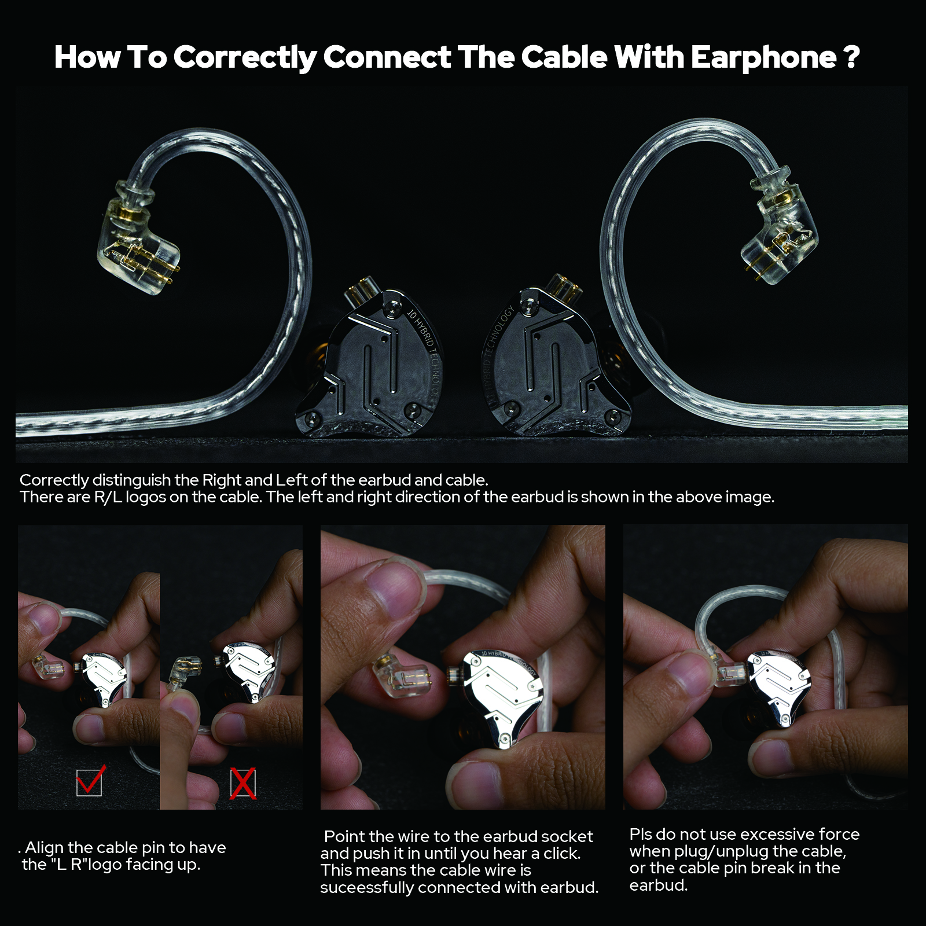

Second. Wear it correctly.

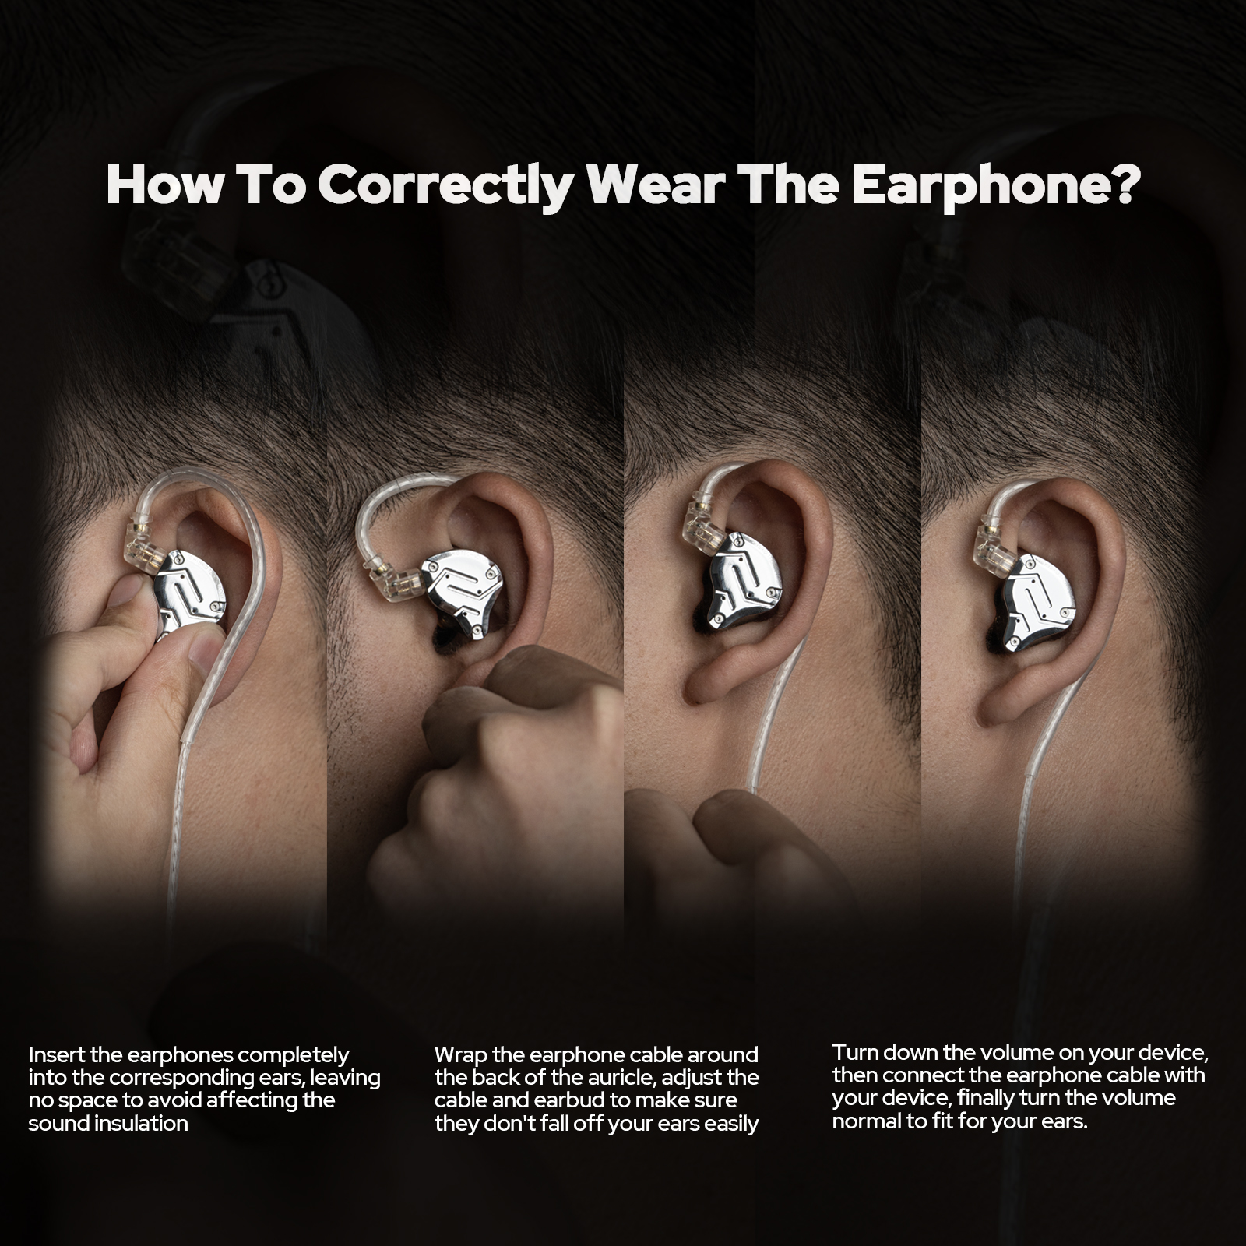

Third, there are different sizes of headphones. Choose a size that fits your ears. If the silicone casing is oiled or soiled due to prolonged use, replace it with a new one regularly to ensure hygiene.

Fourth, when saving the headphone cable, avoid excessive bending of the headphone cable connection (such as plug, distributor cable, headphone inlet). Misuse or misuse can easily lead to tinnitus, tooth decay, broken wires, or broken skin.

